REV. |  | Description |  |  |  |  |  | Date
S00 |  | SPEC ISSUE(NEW MODEL) |  |  |  |  |  | 03/27/2018
S01 |  | 102A-187204  ADD NEW MODEL:ADP-65AE BB |  |  |  |  |  | 07/30/2018
S02 |  | 102A-189026  EMI/RFI setup add 4.EMI/RFI判定條件為under 6dB |  |  |  |  |  | 09/17/2018
00 |  | 102A-18A075  轉量產 |  |  |  |  |  | 10/15/2018
01 |  | 102A-18A178  ADD ADP-65AE BAA & ADP-65AE BBA |  |  |  |  |  | 11/02/2018
02 |  | 102A-193083  ADD ADP-65AE BC |  |  |  |  |  | 03/12/2019
03 |  | 102A-198039  ADD ADP-65AE BD |  |  |  |  |  | 09/02/2019
04 |  | 102A-199154  CHANGE ITEM 4 (C) |  |  |  |  |  | 09/26/2019
05 |  | 102A-202053  ADD ADP-65AE BE |  |  |  |  |  | 02/17/2020
06 |  | 102A-207025  ADD ITEM 3(j) |  |  |  |  |  | 07/10/2020
07 |  | 102A-208140  ADD ADP-65AE BF |  |  |  |  |  | 09/07/2020
08 |  | 102A-20103  ADD ADP-65AE BB1 |  |  |  |  |  | 11/18/2020
09 |  | 102A-20C016  ADD ADP-65AE BG |  |  |  |  |  | 12/08/2020
10 |  | 102A-211004  ADD ITEM 3(k)噪音測試 |  |  |  |  |  | 01/07/2021
11 |  | 102A-227121  CHANGE ITEM 3(k)噪音測試 |  |  |  |  |  | 07/27/2022
12 |  | 102A-22C059  ADD ADP-65AE BH |  |  |  |  |  | 12/16/2022
13 |  | 102A-  ADD ADP-65AE BA2 |  |  |  |  |  | 12/12/2023
14 |  | 102A-245346  CHANG ITEM 5 |  |  |  |  |  | 05/30/2024
 |  |  |  | 台達電子工業股份有限公司  DELTA ELECTRONICS, INC. |  |  | DESCRIPTION :  測試規格(Test Specification)
 | THESE DRAWINGS AND SPECIFICATIONS ARE THE PROPERTY OF DELTA  ELECTRONICS, INC. AND SHALL NOT BE REPRODUCED OR USED AS THE  BASIS FOR THE MANUFACTURE OR SELL OF APPARATUSES OR DEVICES  WITHOUT PERMISSION. |  |  |  |  |  | MODEL NO. :  ADP-65AE B SERIES
 | Date |  | Drawn |  | Design (EE) | Design (ME) | DOCUMENT NAME. :  TS-65AE B SERIES |  | REV.
 | 05/30/2024 |  | 呂翠娥 |  | 林建銘/陳新淵 | 楊基祥/吳岱洋 |  |  | 14
Frame Name:DF-PSLA4V-2R01.DOC SHEET 2 OF 10
MODEL LIST: ADP-65AE BA/ BAA/BA2 /BB/BBA /BB1/ BC/BD/BE/BF/BG/BH

- 測試注意事項內容，未經工程師許可，不可任意變更。
Test Notice contents shall not be changed or revised without engineer permission.

- 此測試規格用於主線測試,所有項目均需被測試,因設備或線速限制無法全數測試時,
需測試worst case, QC需按抽樣標準做抽樣測試.
The production line shall perform all or worst test items/conditions, and QC shall follow the sampling
plan to perform the sampling test.

- 測試注意事項 :
  - 所有ATS測試時，須偵測CONNECTOR端之電壓。
  - Thermal測試環境使用電木。
  - 量測ID PIN電壓時，不可使用電子負載，須使用三用電表或示波器。
  - 測試電容性負載(2200uF)時，電子負載需設定10V Von點。
  - HI-POT測試時AC Cable須使用兩芯線。
  - Common Mode Noise 只須滿足HP規格。
The common mode noise when measure in accordance with IEC 62684 shall not exceed
follow below requirement
The peak-to-peak voltage measured in the frequency range of 10KHz to 100KHz
shall not exceed 1V peak-to-peak.
The peak-to-peak voltage measured in the frequency range of 100KHz to 400KHz
shall not exceed 200mV peak-to-peak
  - ATS與Loop gain測試時，須全程並聯系統電容2200uF，且需要直接加在治具端上，不可
使用電容盒連接。
  - AC on/off 測試必須設定Von點為10V。
  - Surge Load 的測試條件:
輸入電壓 : 100V / 60Hz.
輸出負載 : Surge Load 5A / 0.3S ~ MAX Load 3.33A / 5S。
Current slew rate 1A / usec。
備註:在ATS測試時，抽完surge load 5A 之後，必須增加切為滿載3.33A程式，再進入
UUT off &Load Setup。
  - 測試表面溫升時, 使用#30點溫線。
  - 噪音測試時需B/I 30分鐘，B/I條件輸入電壓100Vac/60Hz輸出負載20V/3.33A，
HP噪音測試若使用AC source測試Fail需再用市電驗證，最終以市電測試結果判定。
HP acoustic noise測試，不測試輸出10%及20% load條件。
內規部分以100Hz~20KHz的條件判定。
(1). 0~Full Load : < 25dB
(2). No Load - 120Vac/60Hz
(3). No Load - 240Vac/50Hz
(4). Nominal Load - 120Vac/60Hz
(5). Nominal Load - 240Vac/50Hz
(6). Maximum Load - 120Vac/60Hz
(7). Maximum Load - 240Vac/50Hz
Table – AC Adapter Acoustic Noise Levels

Frequency  (Hz) | Mag dBA  re 20 µPA |  | Frequency  (Hz) | Mag dBA  re 20 µPA
630 | 5.0 |  | 4.00 k | 12.0
800 | 7.5 |  | 5.00 k | 11.0
1 k | 9.0 |  | 6.30 k | 10.0
1.25 k | 12.0 |  | 8.00 k | 9.0
1.6 k | 11.0 |  | 10.00 k | 8.0
2.0 k | 12.0 |  | 12.50 k | 7.5
2.50 k | 12.0 |  | 16.00 k | 13.0
3.15 k | 12.0 |  | 20.00 k | 20.0

- 手調測試站：
  - Full Load Test: 檢查滿載輸出是否符合規格
  - Min. Load Test: 檢查輕載輸出是否符合規格
  - ID function測試調整如下:
產品輸出電流在3.15A之前，ID電壓準位為6.17V~6.81V；產品輸出電流在3.15A~4A(120%)
之間，ID電壓準位為17Ｖ~19V為正常轉態，轉態時間為50mS ~ 300mS。
此測試項目需滿足常溫(25℃)條件下。
輸出電流3.15A時，其ID電壓已經轉態至(17V~19V)，請短路TR132。
  - OVP Test : (量產後不需測試)
Load Condition : 3.33A
測試方法: 短路R137,檢查輸出電壓是否小於29V, OVP動作模式為Latch off
  - OTP Test :
Load Condition : 3.33A
測試方法：NTC31並聯10kohm電阻,檢查輸出電壓是否shutdown或Latch off.
  - AC On/Off:
Power supply 連續開關機 On= 5秒, Off= 5 秒, 5 次後, 必須無損壞情形。

g. 抽載測試輸出: Connector需掛10uF & 0.1uF的輸出電容做為測試。

- Function test (ATS) procedure：
Input Specification Table:
INPUT VOLTAGE | MINIMUM | MAXIMUM | NOMINAL(RATED)
 | 90Vac | 265Vac | 120Vac
Output Specification Table:
 | OUTPUT |  | MINIMUM |  | MAXIMUM |  | NOMINAL(RATED)
 | Voltage (Vdc) |  | 18.525V |  | 20.475V |  | 19.5V
 | Loading (Amp) |  | 0A |  | 3.33A |  | 3.33A
 | ID(V)轉態前 |  | 6.17 |  | 6.81 |  | 6.49
 | ID(V)轉態後 |  | 17 |  | 19 |  | 18
Test Item |  | Vin |  | Load |  | Spec |  | Remark
Inrush Current |  | 265V/63Hz;  Phase 90º |  | 3.33A |  | shall be limited to a 29% margin of the I²T rating of the input fuse and bridge  rectifier.
Turn On Time |  | 90V/47Hz |  | 3.33A |  | <5000mSec
Hold up Time |  | 100V/50Hz |  | 3.33A |  | >5ms
Rise Time |  | 90V/47Hz& 265V/63Hz |  | 0/0.5/3.33A |  | Output Voltage: The output shall be in regulation within 40mS at 0 to 500mA condition.  (Measured from 10% to 95% regulation) |  | From 10 to 90% voltage, monotonic
Fall Time |  | 90V/47Hz& 265V/63Hz |  | 3.33A |  | <NA |  | From 90 to 10% voltage, monotonic
Line Regulation |  | 90/115/230/265V 47/63Hz |  | 0A |  | 18.525V~20.475V
Line Regulation |  | 90/115/230/265V 47/63Hz |  | 3.33A |  | 18.525V~20.475V
Load/Combine Regulation |  | 90/115/230/265V 47/63Hz |  | 3.33A |  | 18.525V~20.475V
Ripple & Noise |  | 100V/50Hz |  | 0.05A & 3.33A |  | <380mVp-p |  | 0.1uF/10uF  Oscilloscope at 10KHZ to 20MHz bandwidth
Transient Load |  | 90V/47Hz & 265V/63Hz |  | 0.1A--90%Load ＆10%--100%load |  | 18.525V~20.475V |  | Output change from 0.1A to 90 % Load, and from 10 % to 100 % load, slew rate is 1A/us, frequency is 1Hz ~ 5KHz.  Remark:不須計算CPK
Short Circuit Protection |  | 90V/47Hz & |  | 0A & 3.33A  Turn on then short |  | Latch
Short Circuit Protection |  | 265V/63Hz |  | 0A & 3.33A  Turn on then short |  | Latch
Over Current Protection |  | 90/110/230/265Vac |  | 3.33A |  | 5A<OCP <11A  Latch
Input Current |  | 90V/47Hz |  | 3.33A |  | <1.7A
Harmonic Current  Power Factor |  | 120V/60Hz |  | 3.33A |  | >0.5 |  | The source impedance shall be less than 0.1 ohm.
Average Efficiency |  | 230V/50Hz&  115V/60Hz |  | 25%, 50%, 75% & 100% Load |  | >87% |  | Cold
Average Efficiency |  | 230V/50Hz&  115V/60Hz |  | 25%, 50%, 75% & 100% Load |  | 230V/50Hz 需>89%  115V/60Hz 需>88% |  | hot
Pin at No Load |  | 115V/60Hz&  230V/50Hz |  | No Load |  | <150mW
Pin at standby Load |  | 115V/60Hz&  230V/50Hz |  | 0.25W  0.5W  1.0W  1.5W |  | 0.5W  1.0W  1.7W  2.4W
Surge Load 1 |  | 90V/47Hz~  265V/63Hz |  | 3.49A (3minutes)  3.7A (1minutes)  3.81A (30seconds) |  | 18.525V~20.475V |  | Remark:不須計算CPK
Surge Load 2 |  | 100V/50HZ |  | 5A(300ms)  6A(10ms) |  | Vo allowed to drop to 15V minimun |  | Current slew rate 1A/usec  Remark:不須計算CPK
Capacitive Load |  | 90/115/240/265  Vac |  | 3.33A |  |  |  | Add cap.2200uF

Note 1: After completes required DVT test matrix, identifies and selects the worst case condition for the Production MTR. It is not required that all test conditions be tested. Example: If worst case condition for Output Ripple is minimum input voltage and maximum dc load, then that is the test condition to be used.

6. Safety
  - Hi-POT test：
PRIMARY to SECONDARY : Applied 3000 +10%Vac , 60Hz for test . ( Rise time : DC=1Sec, AC=0.1Sec).
Cut off current : Hi-Limit 10mA, Lo-Limit 0.02mA。
Testing time for production line is 1 minute at EVT/DVT stage and 1 Second at PVT/MP stage.
Following is Arcing sense setting at each stage : EVT1: 5mA, EVT2/DVT: 8mA, PVT/MP: 10mA.
  - Insulation Resistance(IR) test :
Primary to Secondary use 500Vdc test, Insulation resistance limit >100Mohm.
  - FG connection test
FG 與Vo GND之間直流阻抗必須在0.9~1.1Mohm之間
6.4 Leakage Current
Class I Equipment (Grounded Equipment)
The total combined leakage current when measure in accordance with IEC 60950-1, 2nd
Edition shall not exceed 30 microamperes when tested at 250 VAC, 50 Hz in a normal
operating condition

7. Burn-in 測試作業規範
Follow Delta Standard Burn-in Condition.

8. Loop/Gain 測試作業規範
Disturbance voltage setting 1.3V

9. EMI/RFI Setup
1. AC power cord 使用1.8m線
2.樣品DC cable放在樣品與dummy load之間,不可跨到AC power cord與接地線
3.Dummy Load放置桌面時, 治具與桌沿切齊
4.EMI/RFI判定條件為under 6dB
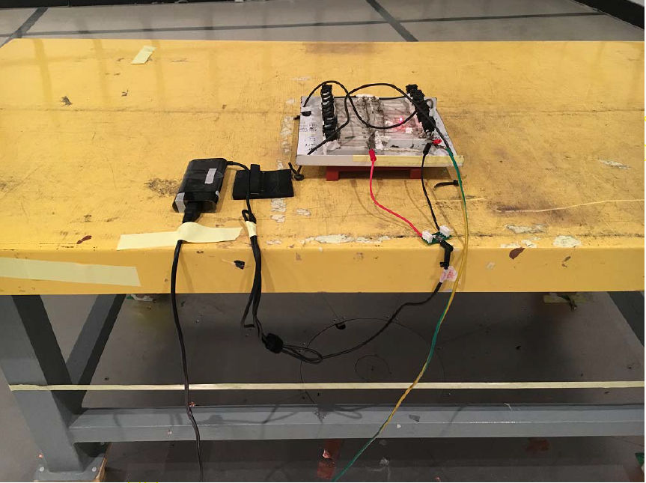

10. Mechanical 包裝測試條件: 請參照台達規範: 10000-0089
(1) Drop Test
a. 條件
Carton weight
~25kg, 高度 60cm
26~50, 高度 45cm
51~75, 高度 35cm
76~100, 高度 30cm
b. 紙箱測試順序
以紙箱之1個稜角/3個稜線/6個面，每次落下試驗可取任一稜角(傾斜角不得超過10度)
c. 試驗步驟如下
Step1. 垂直落下此角 (Corner 2-3-5)
Step2. 由此角引申之最小稜線 (Edge 3-5)
Step3. 由此角引申之次長稜線 (Edge 2-5)
Step4. 由此角引申之最長稜線 (Edge 2-3)
Step5. 最小的面 (Front 5)
Step6. 相對的最小面 (Rear 6)
Step7. 次小的面 (Right 2)
Step8. 相對的次小面 (Left 4)
Step9. 最大的面 (Bottom 3)
Step10. 相對的最大面 (Top 1)
(2) Vibration Test
a. 條件
頻率 5 Hz, 振幅 20 mm, 時間 5 Min.
頻率 10 Hz, 振幅 5 mm, 時間 5 Min.
頻率 15 Hz, 振幅 2.2 mm, 時間 5 Min.
頻率 20 Hz, 振幅 1.25 mm, 時間 5 Min.
* 包裝測試後判定標準:
(1) Drop Test --- 產品 --- 外觀無損壞, 輸出正常, Hi-Pot 測試無不良.
--- 包材 --- 外箱可變形, 產品自身之單體包裝 (PE Bag, 彩盒, 吸塑盒.......)
不得有變形及破損.
(2) Vibration Test --- 產品 --- 外觀無損壞, 輸出正常, Hi-Pot 測試無不良, 包裝材料無損壞.

* 如果參考機種已完成包裝測試，則不需重新測試.
